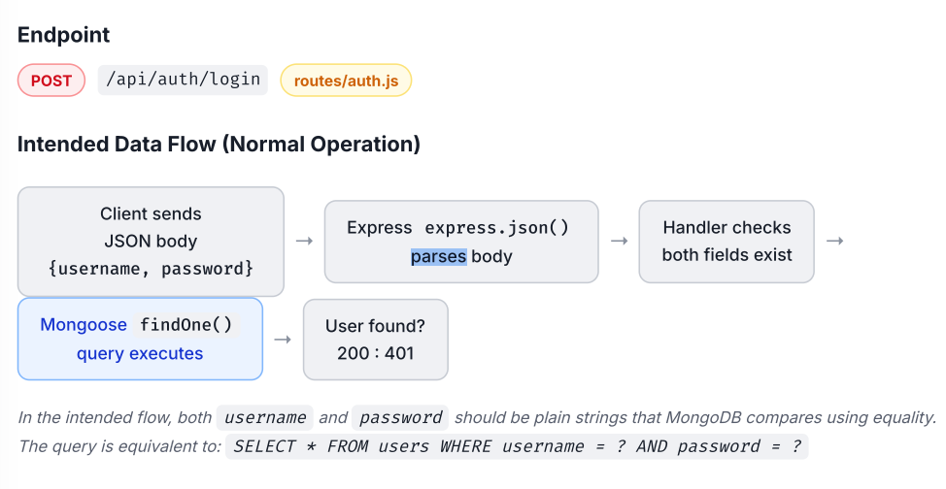
Vulnerable Code Design — NoSQL Injection
3.1 Feature Description & Intended Data Flow
The login feature allows corporate users to authenticate against a MongoDB user collection by submitting a JSON body containing their username and password . On a successful credential match, the server returns a user profile object and a session token. On failure, it returns HTTP 401 with a generic error message.

3.2 Vulnerable Code Snippet
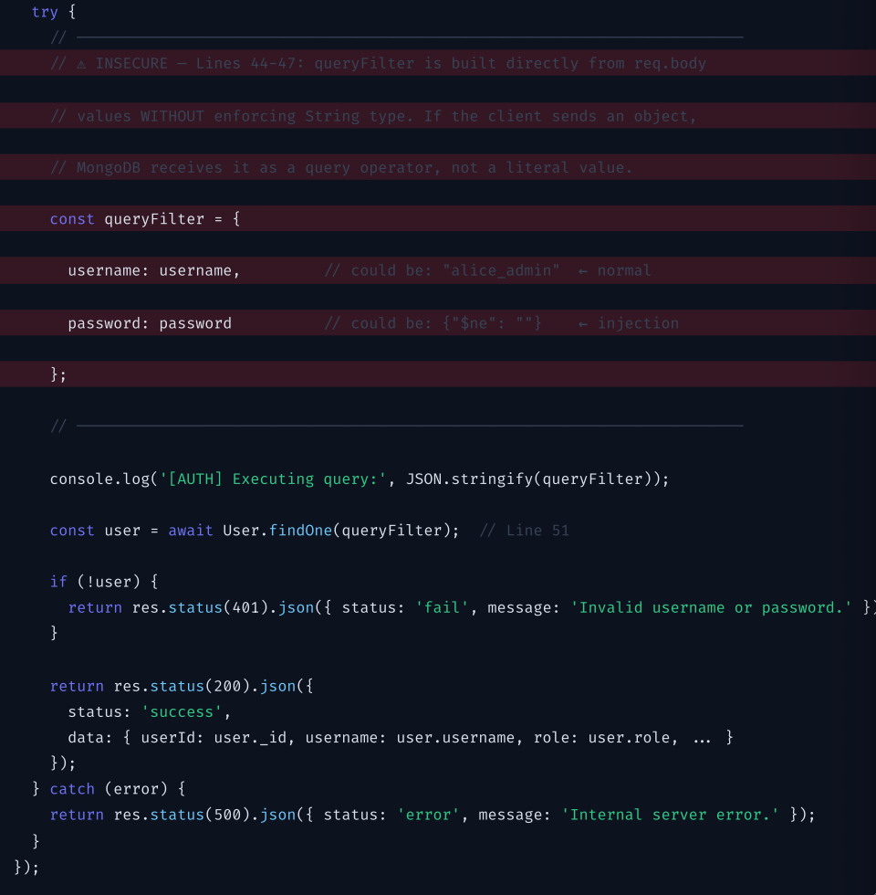
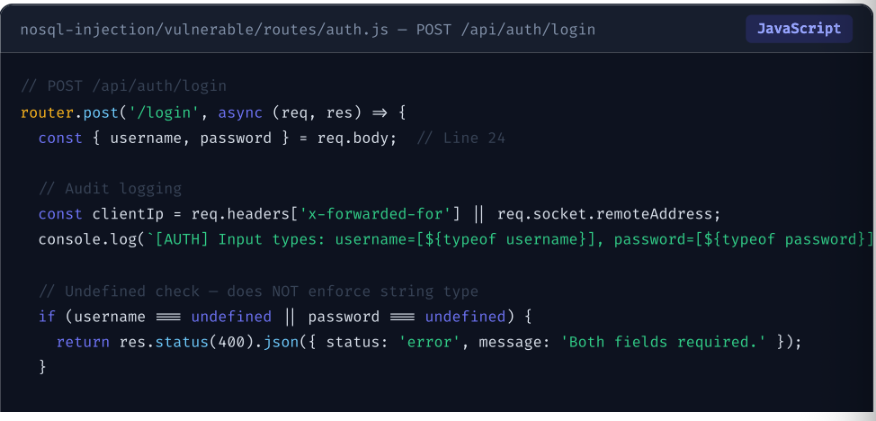

Insecure Lines — Summary Table
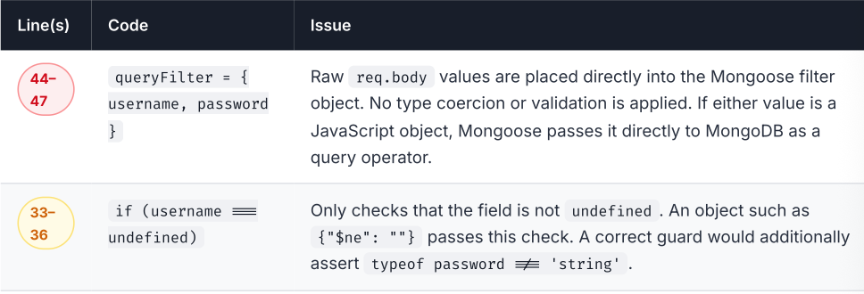

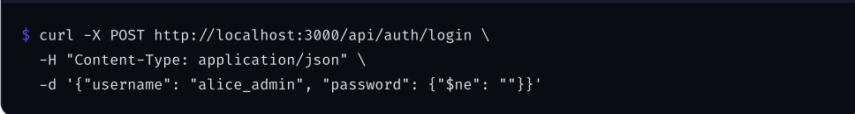
3.3 Why the Input Handling is Unsafe
Express is configured with the express.json() middleware.This middleware fully deserialises the HTTP request body as a JavaScript value Including nested objects. When a client sends the body below, Express produces a JavaScript object where password is not a string, but a plain object containing the MongoDB query operator $ne (not-equal):

What MongoDB Sees
Because queryFilter.password is the object {"$ne": ""} , Mongoose forwards the following queryto MongoDB:
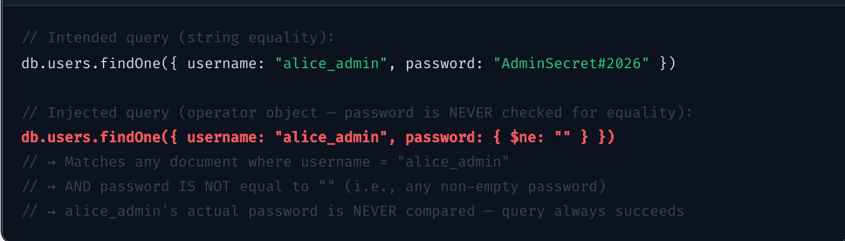

Root Cause Chain
1.express.json() deserialises nested JSON objects from the request body.
2.The handler only checks password !== undefined — an object is not undefined.
3.The object is placed directly into the Mongoose findOne() filter.
4.Mongoose passes the object to the MongoDB driver without coercing it to a string.
Vulnerable Code Design — Path Traversal

4.1 Feature Description & Intended Directory Boundary
The document archive service allows users to read compliance and audit reports stored in a designated public/documents/ directory. The client passes a filename via a query string parameter and the server responds with the file's contents as plain text or JSON.
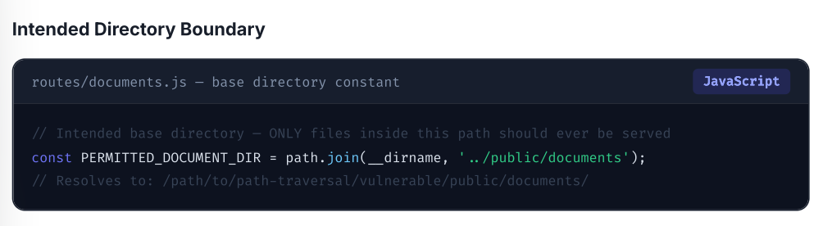

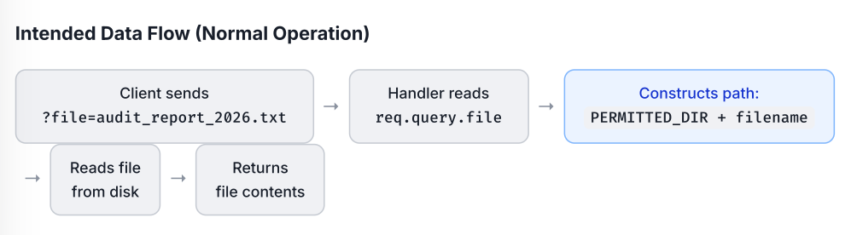

4.2 Vulnerable Code Snippet
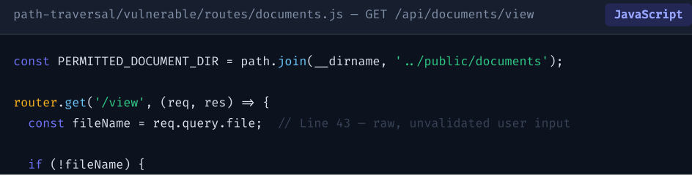
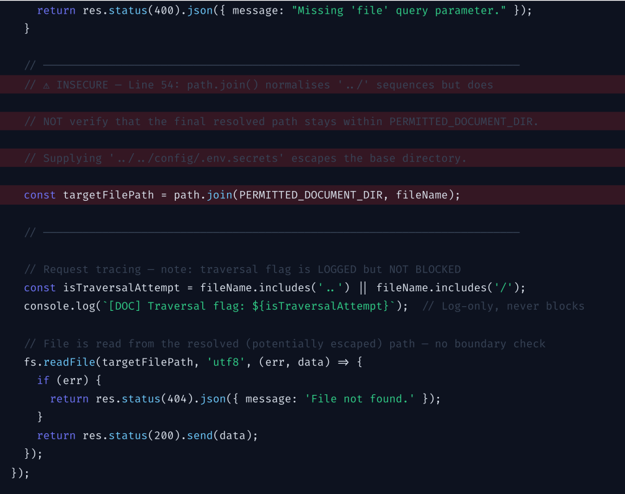

Insecure Lines — Summary Table
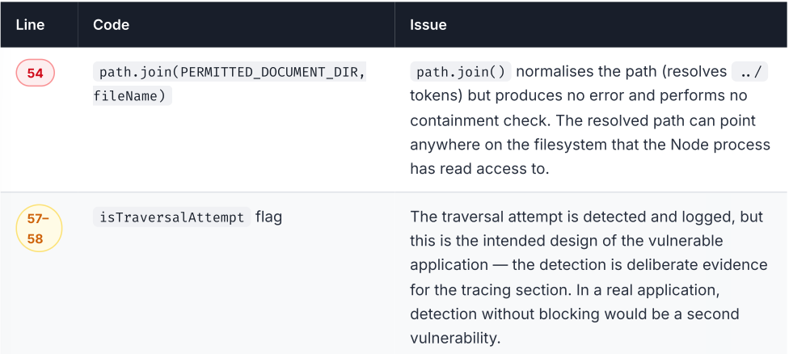

4.3 Why the Path Handling Fails to Enforce the Boundary
Node's path.join() function is a path-construction utility, not a security boundary. It resolves and normalises relative path tokens including (parent directory traversal) producing a clean absolute path. It does not know or care whether the resulting path is inside the intended base directory. There is no exception thrown, no error returned, and no indication in the output that the boundary has been crossed.

Root Cause Chain
1.req.query.file accepts arbitrary user input, including ../ sequences.
2.path.join() normalises the input, producing a valid absolute path outside the permitted directory.
3.The isTraversalAttempt check logs the traversal but does not reject the request.
4.fs.readFile() reads whatever file is at the resolved path — no boundary enforcement exists at the filesystem read stage.

5. Code Comments & Design Notes
This section provides a function-by-function walkthrough of the main components of the application. It explains the purpose of each component, the design decisions made, and the security risks introduced by the vulnerable implementations.

5.1 routes/auth.js — Authentication Handler
Purpose
The authentication handler manages POST /api/auth/login. It reads the username and password from the JSON request body, performs a Mongoose findOne() query against the User collection, and returns the user's profile data and a session token when the credentials match.
Design Decision — Why String Enforcement Is Not Used
The handler intentionally does not enforce typeof username === 'string' or typeof password === 'string'.
The only validation performed is an undefined check on lines 33–36. This allows any non-undefined value, including JavaScript objects, to pass through to the MongoDB query filter.
Risk Introduced
An attacker can send a JSON request containing a nested object in the password or username field. This allows MongoDB query operators to be injected into the query, which can result in authentication bypass.

5.2 routes/documents.js — Document Archive Handler
Purpose
The document archive handler manages GET /api/documents/view?file=. It reads the requested filename from the query string, constructs the target file path using path.join(), and streams the requested file back to the client as plain text or JSON.
Design Decision — Why path.join() Is Used Without a Boundary Check
The handler uses the standard path.join() utility but does not perform a path.resolve() followed by a startsWith() boundary check.
The isTraversalAttempt flag on line 57 detects sequences in the filename and logs a warning. However, the request is deliberately not rejected. This behaviour is intentional for the tracing and detection section of the assignment.
Risk Introduced
An attacker can use ../ path traversal sequences in the file parameter to navigate outside the intended documents directory.
This may allow access to any file that the application process has permission to read, potentially exposing configuration files, credentials, secrets, and other sensitive resources.

5.3 routes/documents.js — Document Listing Handler
Purpose
The document listing handler manages GET /api/documents/list.
It reads the public/documents/ directory using fs.readdirSync() and returns a list of .txt files as JSON.
Security Status
This endpoint is considered safe because it reads only from a fixed, hardcoded directory and exposes filenames rather than the contents of the files.
Risk Introduced
None.
The endpoint operates only on the pre-validated directory constant and does not allow the client to specify an arbitrary filesystem path.
5.6 models/User.js — Mongoose User Schema
Purpose
The User model defines the structure of user documents stored in MongoDB.
The schema contains the following fields:
- username — unique, trimmed string
- password — plain string
- fullName
- role — enum containing Administrator, Security Analyst, Auditor, and Staff
- department
- accountStatus — Active or Suspended
- createdAt
Design Decision — Plain-Text Passwords
Passwords are intentionally stored as plain strings.
This is a deliberate design decision for the assignment because the primary focus is the query-level NoSQL injection vulnerability rather than password-storage security. Introducing password hashing using bcrypt would add additional complexity without contributing to the demonstration of the specific vulnerability.
Risk Introduced
The password field is defined as a String in the Mongoose schema. However, Mongoose's type coercion does not prevent an object from being supplied directly as a query filter value.
Schema type enforcement primarily applies when documents are created or updated.
It does not provide sufficient protection when untrusted objects are supplied directly to a findOne() query filter.
Therefore, an attacker-controlled object can potentially contain a MongoDB query operator and modify the behaviour of the authentication query.
Normal Behavior Evidence
6.1 NoSQL Injection Tests

Test ID | Test Case | Purpose | Request | Expected Result | Status
NSQL-01 | Endpoint Check | Confirms the server is running and the endpoint is accessible. | GET /api/health | HTTP 200 | Pass
NSQL-02 | Valid Authentication | Confirms valid credentials successfully authenticate. | POST /api/auth/login | HTTP 200 | Pass
NSQL-03 | Invalid Authentication | Confirms an incorrect password is rejected. | POST /api/auth/login | HTTP 401 | Pass
6.2 Path-Traversal Tests
Test ID | Test Case | Purpose | Request | Expected Result | Status
PT-01 | Valid Document Retrieval | Confirms that a legitimate document inside the permitted directory can be retrieved. | GET /api/documents/view?file=audit_report_2026.txt | HTTP 200 with the requested document | Pass
PT-02 | Non-Existent Document | Confirms that the application correctly handles a request for a file that does not exist. | GET /api/documents/view?file=missing_record_123.txt | HTTP 404 | Pass

